Topic 1: Biochemistry and the Molecules of Life

Organic Compounds
Most of the molecules in living things are organic molecules, meaning that they contain carbon. The fact that carbon has 4 electrons in its outermost shell means that it is capable of covalently bonding with other atoms to fill its outermost shell. Organic molecules typically involve carbon bonded to hydrogen, oxygen, nitrogen and other carbon atoms. Carbon atoms bonded to each other form long chains to which atoms or groups of atoms can be attached.
- Organic Molecules - Molecule that always contains carbon (C) and hydrogen (H); organic molecules are associated with living things.
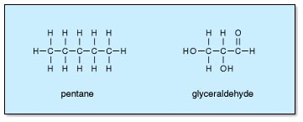
- Electrons - Subatomic particle that has almost no weight and carries a negative charge; orbits in a shell about the nucleus of an atom.

Covalently Bonding - Chemical bond between atoms that results from the sharing of a pair of electrons.

Ionic Bonding – Chemical Bonds between atoms that results from donation or acceptance of electrons
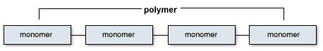

Polymer Synthesis
Many organic molecules consist of subunits, called monomers, that are joined together to form what are referred to as polymers.
- Monomers - One of the similar or identical molecules of which a polymer is made.
- Polymers - A macromolecule made by joining many similar or identical molecules [monomers] through similar or identical bonds.
Monomers are joined together by condensation (or dehydration) reactions, which form water molecules in the process. Polymers can also be broken into monomers by hydrolysis reactions, which use water molecules in the process.
Polymers are broken down by Hydrolysis, which is the splitting of a covalent bond by the addition of water.
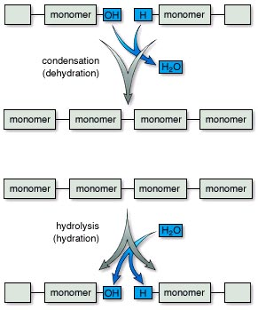

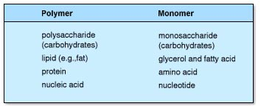
Four Kinds of Organic Molecules
There are 4 major kinds of organic molecules, carbohydrates, lipids, proteins and nucleic acids. Each of these exists as a polymer, composed of the monomers shown in the table.
- Carbohydrates - Organic compound characterized by the presence of CH₂O groups; includes monosaccharides, disaccharides, and polysaccharides; quick energy for the cell
- Lipids - Organic compound that is insoluble in water; notably fats, oils, and steroids; contain C,H and a little O.
- Proteins - Organic compound that is composed of either one or several polypeptides; used for structure, hormones, or enzymes; contain C,H,O,N, and sometimes S

Nucleic Acids - A polymer of nucleotides; contains the genetic information/code of the cell
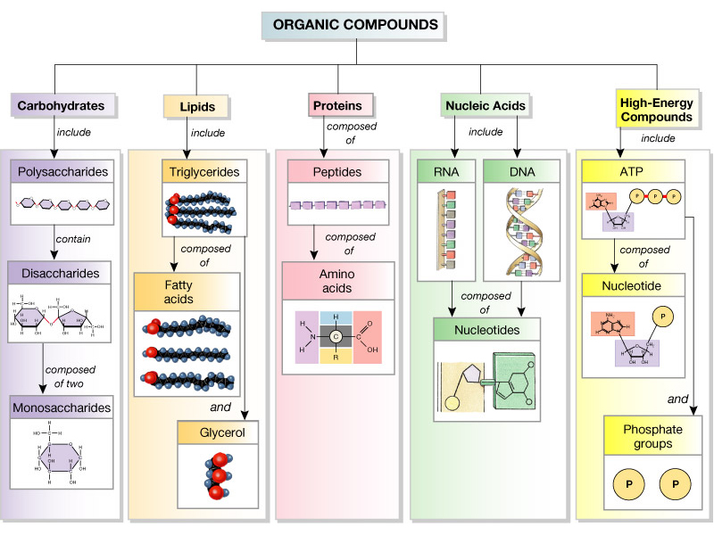

Topic 2: Cells and the Organization of Life

Introduction
Eukaryotic cells are larger and more complex than prokaryotic cells. They include many organelles, membrane-bound structures with specialized functions. This generalized animal cell shows the prominent nucleus, extensive membrane system of the endoplasmic reticulum, mitochondria, other organelles and numerous ribosomes.
- Eukaryotic Cells - Cell that possesses a nucleus and the other membranous organelles characteristic of complex cells.
- Prokaryotic Cells - Cell lacking a nucleus and the membranous organelles found in complex cells; bacteria, including cyanobacteria.
- Organelles - Specialized structure within cells (e.g., nucleus, mitochondria, and endoplasmic reticulum).
- Nucleus - I. The distinctive organelle of a eukaryotic cell, consisting of a membranous envelope in which the chromosomes reside
- Cytoplasm – The internal components of the cell including both organelles (if present) and the cytosol
- Cytosol – the fluid component of the cytoplasm, water and water soluble compounds.
- Cell Membrane – the external boundary of the cell made of the Phospholipid bilayer
Animal Cell Review
- Eukaryotic Cells - Cell that possesses a nucleus and the other membranous organelles characteristic of complex cells.
- Organelles - Specialized structure within cells (e.g., nucleus, mitochondria, and endoplasmic reticulum).
- Nucleus - The distinctive organelle of a eukaryotic cell, consisting of a membranous envelope in which the chromosomes reside;
- Endoplasmic Reticulum - Membranous system of tubules, vesicles, and sacs in cells, sometimes having attached ribosomes. Rough ER has ribosomes; smooth ER does not.
- Mitochondria - Membranous organelle in which aerobic cellular respiration produces the energy carrier ATP.
- Ribosomes - Minute particle that is attached to endoplasmic reticulum or occurs loose in the cytoplasm and is the site of protein synthesis.
- Golgi apparatus – Stacked set of membranes that modifies, transports, and packages materials for export
Plant Cells
This plant cell has some structures not found in animal cells. These include a cell wall outside of the plasma membrane, a large central vacuole, and chloroplasts.
- Cell Wall - Protective barrier outside the plasma membrane of plant and certain other cells.
- Plasma Membrane - Membrane surrounding the cytoplasm that consists of a phospholipid bilayer with embedded proteins; functions to regulate the entrance and exit of molecules from cell.
- Vacuole - Membranous cavity, usually filled with fluid.
- Chloroplasts - Membranous organelle that contains chlorophyll and is the site of photosynthesis.

Organization of Life
Life is organized in ways from the simplest to the complex.
At the multicellular level, specialized cells develop in such a manner
where they structure helps them better perform a specific function).

Topic 3: Cell Transport

Diffusion Introduction

Water and small, non-charged molecules have no difficulty crossing the lipid portion of the membrane. Ions and charged molecules cannot cross easily, nor can large molecules. It is important that many types of substances be able to enter or leave cells. There is a variety of mechanisms by which this occurs, some requiring energy and some utilizing carrier proteins.
- Lipid - Organic compound that is insoluble in water; notably fats, oils, and steroids.
- Ions - Atom or group of atoms carrying a positive or negative charge.
- Energy - Capacity to do work and bring about change; occurs in a variety of forms.
- Carrier Protein - Protein molecule that combines with a substance and transports it through the plasma membrane.
Gas Exchange in the Lungs of Humans
Gas exchange in the lungs occurs by diffusion. Carbon dioxide (CO₂) will follow its concentration gradient into the alveolus, oxygen (O₂) will follow its concentration gradient into the capillary.
- Alveolus - (pl, alveoli) - Air sac of a lung.
- Capillary - Microscopic vessel connecting arterioles to venules and through the thin walls of which substances either exit or enter blood.
Osmosis
Osmosis is the diffusion of water across a membrane. Like other molecules, water will move from an area of high concentration to an area of low concentration. The more solute there is in a solution, the lower the concentration of water in that solution. There is terminology to describe concentration differences between two solutions. A solution with higher solute concentration is hypertonic relative to one with lower solute concentration. Conversely, a solution with lower solute concentration is hypotonic relative to one with higher solute concentration. If two solutions have the same concentration they are isotonic. Water will move from a hypotonic to a hypertonic solution.
- Osmosis - Movement of water from an area of higher concentration of water to an area of lower concentration of water across a differentially permeable membrane.
- Diffusion - Movement of molecules from a region of higher concentration to a region of lower concentration.
- Solute - Substance dissolved in a solvent to form a solution.
- Hypertonic - Solution that has a higher concentration of solute and a lower concentration of water than the cell.
- Hypotonic - Solution that has a lower concentration of solute and a higher concentration of water than the cell.

Facilitated Diffusion

Both simple and facilitated diffusion involve a substance following its concentration gradient, from high to low concentration. If the substance is lipid soluble, it readily passes through the membrane. If it is not lipid soluble, it can cross the membrane only with a specific carrier protein.

Active Transport

Introduction
Active transport involves a protein which uses ATP to pump molecules against their concentration gradients. The same protein may be used to pump two different substances in opposite directions. This is the case for the very important sodium-potassium pump.
- Active Transport - Transfer of a substance into or out of a cell from a region of lower concentration to a region of higher concentration by a process that requires a carrier and an expenditure of energy.
- ATP - Adenosine Triphosphate (ATP) - Nucleotide with three phosphate groups. The breakdown of ATP into ADP 1 Pj makes energy available for energy-requiring processes in cells.
Sodium-Potassium Pump - Transport protein in the plasma membrane that moves sodium ions out of and potassium ions into animal cells; important in nerve and muscle cells.

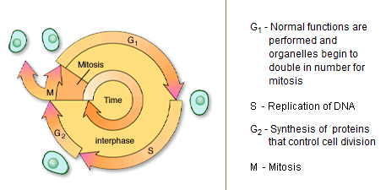Topic 4: Cell Division

Introduction
Mitosis is one of the stages in the life cycle of a cell. It refers to the division of the nucleus.
- Mitosis - Type of cell division in which daughter cells receive the exact chromosome and genetic makeup of the parent cell; occurs during growth and repair.
- Nuclei - Cell organelles containing most of the genetic material of the cell; collection of nerve cell bodies within the central nervous system; center of an atom consisting of protons and neutrons.
Stages of Mitosis
Mitosis is the process by which the contents of the eukaryotic nucleus are separated into 2 genetically identical packages. Chromosomes replicate prior to the beginning of mitosis. As mitosis begins they condense and become visible under a light microscope. They appear as sister chromatids joined at the centromere. Mitosis is divided into 4 stages. During prophase, the nuclear envelope disintegrates and a spindle of microtubules forms. Centrioles may help organize the spindle as in this animal cell. The chromosomes begin to move toward the midplane of the spindle. When they are on the midplane with centromeres attached to spindle fibers, the second stage, metaphase has been reached. Metaphase yields to anaphase as the centromeres separate and the sister chromatids, now termed chromosomes, are pulled toward opposite poles of the spindle. During the final stage, telophase, a nuclear envelope forms around each set of chromosomes, the spindle disappears and the chromosomes decondense. The result is 2 nuclei, each with an identical set of chromosomes. Cytokinesis is the division of the cell contents outside of the nucleus. It occurs with both mitosis and meiosis. In cells without walls, it is accomplished by pinching of the cell. In plant cells, the wall prevents pinching; instead vesicles line up along the middle of the cell. As they fuse they form the separation between daughter cells.
- Eukaryotic Cell - Cell that possesses a nucleus and the other membranous organelles characteristic of complex cells.
- Chromosome - Rodlike structure in the nucleus seen during cell division; contains the hereditary units, or genes.
- Sister Chromatid - One of two genetically identical chromosomal units that are the result of DNA replication and are attached to each other at the centromere.
- Centromere - Constricted region of a chromosome where sister chromatids are attached to one another and where the chromosome attaches to a spindle fiber.
- Prophase - Mitosis phase during which chromatin condenses so that chromosomes appear.
- Microtubule - Organelle composed of 13 rows of globular proteins; found in multiple units within other organelles, such as the centriole, cilia, flagella, as well as spindle fibers.
- Centriole - Short, cylindrical organelle in animal cells that contains microtubules in a 9 1 0 pattern; present in a centrosome and associated with the formation of basal bodies.
- Metaphase - Mitosis phase during which chromosomes are aligned at the metaphase plate (equator) of the mitotic spindle.
- Telophase - Mitosis phase during which the diploid number of daughter chromosomes are located at each pole.

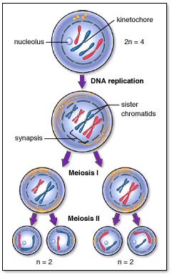
Meiosis
The ultimate goal of the process of meiosis is to reduce the number of chromosomes by half. This must occur prior to sexual reproduction. The cell at the top contains two homologous pairs of chromosomes, for a total of four chromosomes. The final products of meiosis, four daughter cells, each contain one chromatid from each original homologous pair, for a total of two chromosomes. There are two stages of meiosis to accomplish this task
- Sexual Reproduction -Reproduction that occurs through fusion of two gametes

Meiosis I reduces the chromosome number in half, but each chromosomes contains two sister chromatids. Meiosis II
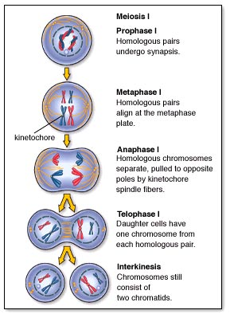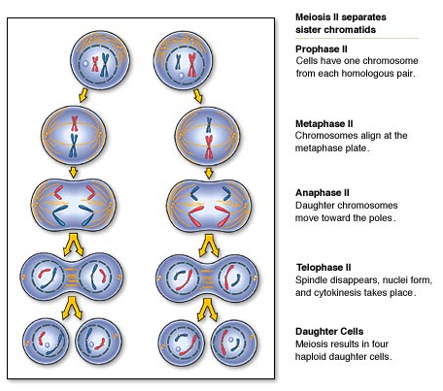
Meiosis is the process by which a diploid nucleus divides twice to produce 4 haploid nuclei. The divisions are called meiosis I and meiosis II. In the life cycles of diploid organisms meiosis precedes sexual reproduction. Among animals, the products of meiosis are gametes-eggs or sperm. DNA is replicated prior to the start of meiosis. The identical sister chromatids are joined at the centromere as in mitosis. Unlike in mitosis, homologous chromosomes pair with one another. These pairs intertwine during early prophase of the first meiotic division and may exchange segments. This exchange is called crossing over. During prophase I, the nuclear envelope disappears and the spindle forms. The homologous pairs lie side by side as they reach the midplane of the spindle and attach to spindle fibers in Metaphase I. Metaphase ends and Anaphase I begins as the partners in each pair of homologous chromosomes separate as they are pulled toward opposite poles of the spindle. These chromosomes still consist of sister chromatids joined at their centromeres. During Telophase I the spindle disappears, nuclear membranes may re-form and the 2 nuclei, each containing a haploid set of chromosomes, are separated as cytokinesis divides the cytoplasm. Prophase II begins with the formation of a spindle and the still duplicated chromosomes move toward its mid-plane. At Metaphase II they are lined up and attached to spindle fibers. Anaphase II begins when centromeres separate and sister chromatids, now considered chromosomes, begin moving in opposite directions. During Telophase II the nuclear membrane re-forms, the spindle disappears and cytokinesis divides the cytoplasm. The result is 4 haploid cells.

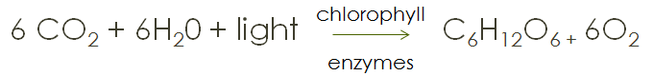
Topic 5: Cellular Energy (Photosynthesis and Respiration)

Photosynthesis
Plants:
- Autotrophs – they make their own sugars during photosynthesis = Producers - Produce food for all other organisms

Animals:
- Heterotrophs – must get their sugars (carbohydrates) for energy from other sources = Consumers – Consume the food provided by plants

Sun
Ultimate source of energy because it provides the energy for the plants which is then passed down to other organisms

Photosynthesis
- The process by which plants convert the sun’s energy, water and carbon dioxide to sugar and oxygen (a by-product)
- Takes place in the chloroplasts
- Chlorophyll is the molecule that receives the sun’s energy
- Chloroplasts are in the mesophyll cells of the leaves and stems (green parts) just below the surface of the leaf (or stem)

There are two major reactions in photosynthesis
- Light Dependent reactions
  - Aka Light Reactions
  - Aka photolysis
  - Light energy is absorbed by chlorophyll, which uses the energy to split water. Oxygen is released to the outside of the cell, the “H” part of H₂O is carried to the dark reactions with NADPH
  - Some ATP (energy) is made here—will be used up in Light Independent reactions
- Light Independent reactions
  - Aka Dark Reactions
  - Aka Carbon fixation (Calvin Cycle)
  - CO₂ from the outside is combined with the “H” part of NADPH to make sugars for the cell
    - NADP+ goes back to light dependent reactions
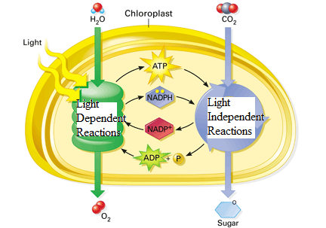
  - ATP is used to combine the CO₂ and H
    - ADP goes back to light dependent reactions

Respiration
Cellular respiration occurs in the mitochondria of eukaryotic organisms. It is composed of three major steps
- Glycolysis -- glucose is split into 2 3-carbon compounds and a small amount of energy is released.
  - Cytoplasm of all cells
- Kreb’s cycle – takes 3-carbon compounds and breaks them down into carbon dioxide
  - Inner part of mitochondria (matrix)
- Electron transport chain – takes electron carriers and materials to create a concentration gradient that ultimately creates ATP
  - Inner folds of mitochondria (cristae)
- Respiration - I. Breathing [external respiration]; II. oxidative metabolism in which an inorganic substance, usually oxygen, is used as the final electron [hydrogen] acceptor; compare with fermentation.
- Glycolysis - Metabolic pathway found in the cytoplasm that participates in aerobic cellular respiration and fermentation; it converts glucose to two molecules of pyruvate.
- Glucose - Six-carbon sugar that organisms degrade as a source of energy during cellular respiration.
- Energy - Capacity to do work and bring about change; occurs in a variety of forms.
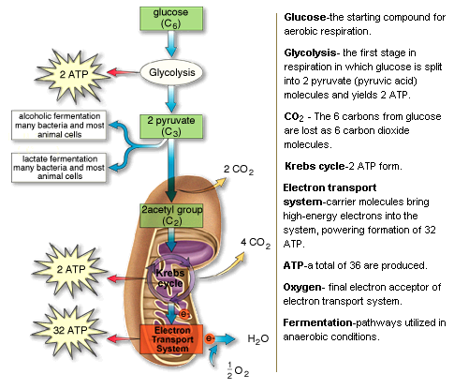
In the absence of oxygen, some organisms will use the products of glycolysis and go through fermentation.
- Alcoholic fermentation—makes alcohol and CO₂ as the byproducts. Creates no ATP, but “refreshes” carriers so glycolysis can continue
- Lactic acid fermentation—makes lactic acid as the byproduct. Creates no ATP, but “refreshes” carriers so glycolysis can continue

Topic 6: DNA and its Processes
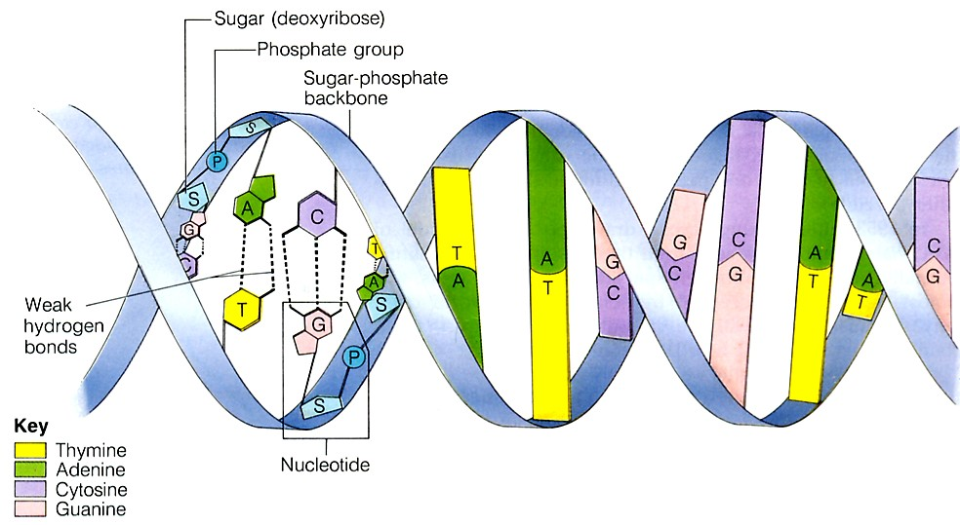

DNA Structure
Deoxyribonucleic acid (DNA) is an important biomolecule that contains our genetic code. Here is a diagram of the double helix model of DNA. Note that the monomers/building blocks of DNA are called nucleotides. Each nucleotide contains three parts
- Sugar (deoxyribose)
- Phosphate group
- Nitrogenous base (4 kinds)

DNA Replication
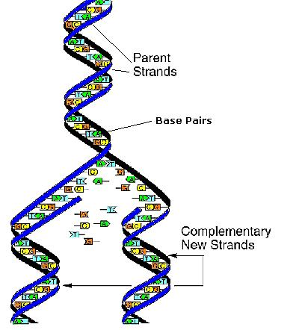
In order for new cells to pass on the genetic code, DNA must be copied inside of cells. In eukaryotic cells, this takes place inside of the nucleus, which stores the cell’s DNA. In prokaryotes, the process of copying DNA occurs in the cytoplasm. Regardless of location, the process is known as replication. Two daughter strands are formed.
- The double helix is opened up by breaking the weak hydrogen bonds
- An enzyme (DNA polymerase) comes in and adds new bases to the open strand
  - It follows base pairing rules: Adenine pairs with Thymine (straight letters A-T go together) and Cytosine pairs with Guanine (curvy letters G-C go together)
- At the end, two identical strands of DNA are formed.
- These strands are said to be complementary to each other because they follow the base pairing rules
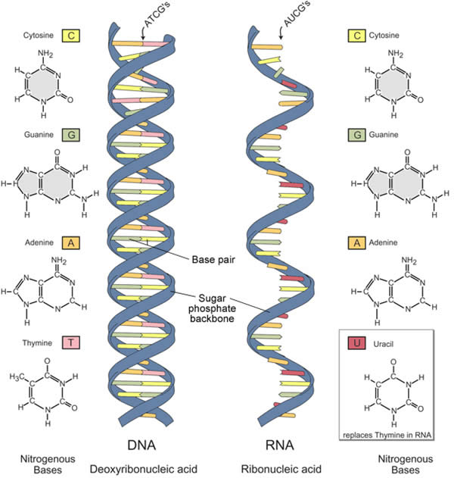

RNA Structure
Ribonucleic acid (RNA) is a similar molecule to DNA.
However, it has some key differences.
 | Deoxyribonucleic acid (DNA) | Ribonucleic acid (RNA)
Number of strands | 2 | 1
Sugar | Deoxyribose | Ribose
Base pairs | A-T G-C | A-U G-C

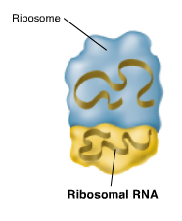
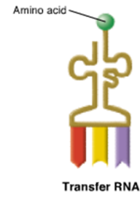
In addition to those differences, there are three different types of RNA. These different types have various shapes and functions.
Messenger RNA (mRNA) carries the transcripted message from DNA to the ribosome to make proteins
Transfer RNA (tRNA) brings the amino acids to the ribosome for protein synthesis
Ribosomal rna (rRNA) is a component of the ribosome and the site of protein synthesis
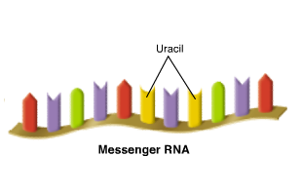

Transcription
This occurs in the nucleus of eukaryotes. In the process of transcription, an mRNA transcript is made using the double helix as a template. The double-stranded molecule of DNA separates along the hydrogen bonds. An enzyme called RNA polymerase adds in corresponding base pairs. However, instead of using Thymine to match up with Adenine, Uracil is used. For RNA, the base paring rules are A-U and G-C. At the end of this process, one piece of mRNA is created. It is complementary to the strand of DNA is was formed from.
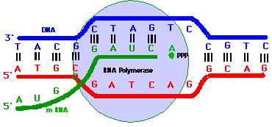

Translation
This process occurs in the cytoplasm. In the process of translation, the piece of mRNA is read by the ribosome in groups of three letters (codons). Each 3-letter portion of mRNA is referred to as a codon and codes for a specific amino acid. These codes match up to the anticodons on the bottom of the tRNA molecules. The corresponding tRNA molecule brings in the correct amino acid (building block of proteins). The ribosome joins the amino acids together to make a protein.
The diagram on the left shows replication, transcription, and translation all happening in the cell. The diagram on the right shows a chart of the 64 codons that make up the genetic code and the 20 amino acids that match up.
Each 3-letter portion of mRNA is referred to as a codon and codes for a specific amino acid. These codes match up to the anticodons on the bottom of the tRNA molecules.
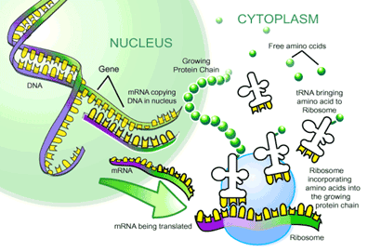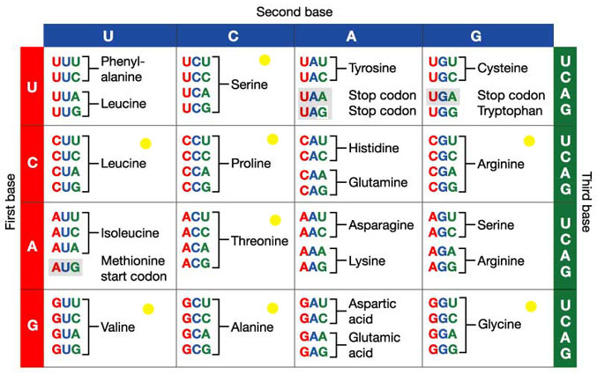
Mutations
Many different types of mutations can occur. They can either affect a few nucleotides (point mutations) or affect large portions of DNA (chromosomal mutations). These will ultimately affect the shape and size of the protein constructed, and the appearance of the cell or organism.
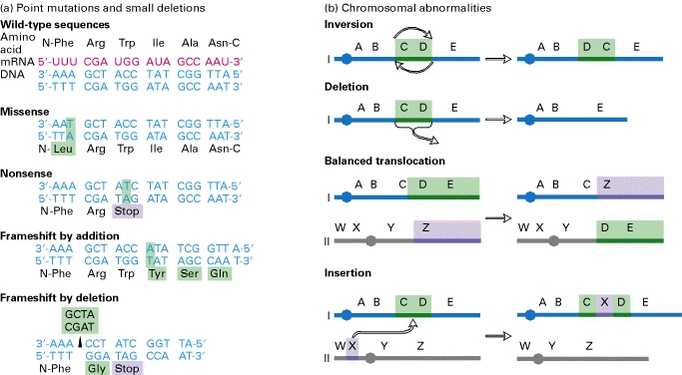

Topic 7: Mendelian and Human Genetics
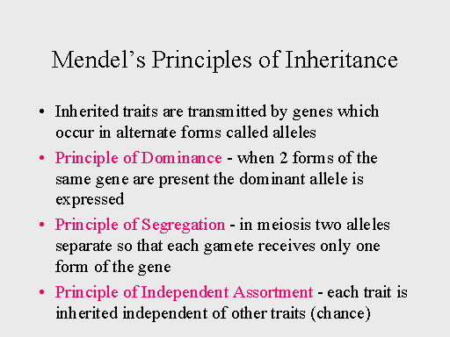
Introduction
Gregor Mendel was a priest who worked in a monastery. He was responsible for maintaining the garden. As he bred pea plants, he noted important patterns about how the traits of the plant (he called them factors) were passed down. Mendel came up with important principles (to the right) to sum up his findings
Genetics is a complex field with lots of details to keep straight. But when you get a handle on some key terms and concepts, including the structure of DNA and the laws of inheritance, you can start putting the pieces together for a better understanding of genetics.

The Scientific Language of Genetics
From chromosomes to DNA to dominant and recessive alleles, learning the language of genetics is equivalent to learning the subject itself. The following key terms are guaranteed to appear frequently in your study of all things genetic:
- Alleles: Alternative forms of a gene
- Autosomal chromosome: A nonsex chromosome
- Chromosome: A linear or circular strand composed of DNA that contains genes
- Diploid: An organism with two copies of each chromosome
- DNA: Deoxyribonucleic acid; the molecule that carries genetic information
- Dominant: A phenotype or allele that completely masks the presence of the other, recessive allele in the heterozygote
- Gene: The fundamental unit of heredity; a specific section of DNA within a chromosome
- Genotype: The genetic makeup of an individual; the allele(s) possessed at a given locus
- Heterozygote: An individual with two different alleles of a given gene or locus
- Homozygote: An individual with two identical alleles of a given gene or locus
- Locus: A specific location on a chromosome
- Phenotype: The physical characteristics of an individual
- Recessive: A phenotype or allele exhibited only when homozygous
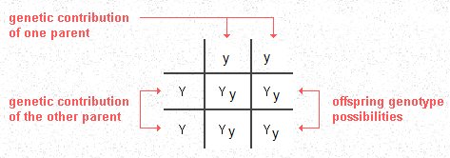
The Punnett Square is a tool used to predict the genotypes and phenotypes of offspring. Punnett Squares have the parent gametes on the outside, and the products of fertilization are shown on the inside. This square only shows one trait, so it is for a monohybrid cross. These are probabilities, not guarantees.

Uncover Inheritance Based on Genotype and Phenotype Ratios
When solving genetics problems, it pays to know what patterns to look for. The parent genotypes and offspring phenotypic ratios in this table can help you figure out what kind of inheritance is at work.
Parent Genotypes | Offspring Phenotypic Ratio | Type of Inheritance
Aa x Aa | 3 A_ : 1 aa | Simple dominance, monohybrid cross
Aa x Aa | 1 AA : 2 Aa : 1 aa | Incomplete dominance
AaBb x AaBb | 9 A_B_ : 3 A_bb : 3 aaB_ : 1 aabb | Dihybrid cross

Genetics: Understanding Chromosome Disorders

CHROMOSOMAL ABNORMALITIES
Chromosomal abnormalities, in the form of nondisjunction, are very common among humans. It's estimated that up to half of all miscarriages are due to some form of chromosome disorder. Sex chromosome disorders are the most commonly observed type of aneuploidy in humans, because X-chromosome inactivation allows individuals with more than two X chromosomes to compensate for the extra "doses" and survive the condition.

Nondisjunction occurs when chromosomes fail to separate evenly during either Meiosis I or Meiosis II. This results in the incorrect number of chromosomes being passed down to the offspring.
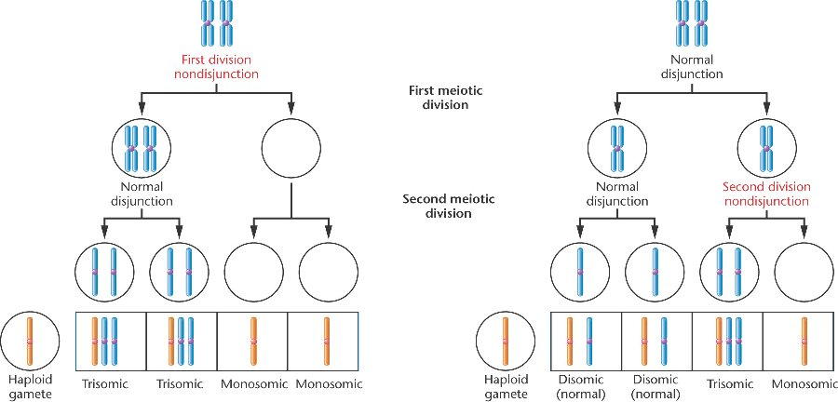

Three common categories of nondisjunction results crop up in humans:
- Monosomy: Occurs when one chromosome lacks its homolog. (EX Turner’s syndrome [45 X]
- Trisomy: Occurs when one extra copy of a chromosome is present. (EX: Trisomy 21—Down’s syndrome…3 copies of the 21st chromosome)(EX: Kleinfelters…3 copies of sex chromosomes [47 XXY]
- Polyploid: Occurs when an entire extra set of chromosomes is present. This is fatal in animals, but fine for plants (EX: Strawberries are Octoploid..they have 8 sets instead of 2)

Most chromosome conditions are referred to by category of aneuploidy followed by the number of the affected chromosome. For example, trisomy 13 means that three copies of chromosome 13 are present.

POINT ABNORMALITIES
Sometimes mutations occur on a much smaller scale that cause genetic disorders. Below is a list of genetic diseases. Autosomal diseases are not linked to a gender, they are on chromosomes 1-22. Sex-linked traits are found on the X chromosome and tend to be present more in males (who only have one X, so they cannot mask a negative recessive trait with a second X)
Disease | Type | Effects
Sickle-cell anemia | Autosomal recessive | Changes shape of RBS; not as good at picking up O₂
Color-blindness | Sex-linked | Difficulty discerning certain shades of color
Huntingdon’s disease | Autosomal dominant | Degrades nerve cells, leads to muscle and cognitive problems
DETECTING ABNORMALITIES
The use of pedigrees (left) and karyotypes (right) can be helpful in determining how a genetic disease is being passed down or if a person has a genetic disease.
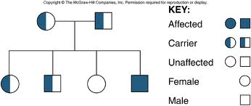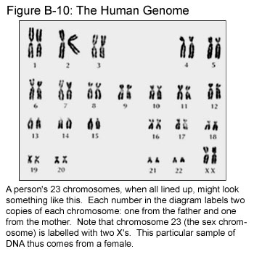

Topic 8: Evolution
Mechanism for Evolution
Charles Darwin concluded that biological evolution occurs as a result of natural selection, which is the theory that in any given generation, some individuals are more likely to survive and reproduce than others. In order for natural selection to occur in a population, several conditions must be met:
- Individuals in the population must produce more offspring than can survive. Human beings are somewhat unique among living things in that we can make conscious choices about how many offspring we have. Most other organisms, however, produce as many offspring as they can.
- Those individuals must have different characteristics. During Darwin’s time, no one knew where these differences came from. Now scientists know that differences in organisms arise due to mutations in DNA combined with the mixing of genetic information during sexual reproduction.
- Offspring must inherit some characteristics from their parents. During Darwin’s time, the laws of inheritance were just beginning to be figured out, so Darwin didn’t know exactly how parents passed on their traits. Modern scientists know that traits are inherited when parents pass genes on to their offspring.
- Organisms with the best-suited characteristics for their environment are more likely to survive and reproduce. This is the heart of natural selection. If there’s competition for survival and not all the organisms are the same, then the ones with the advantageous traits are more likely to survive. If these traits can be inherited, then the next generation will show more of these advantageous traits.
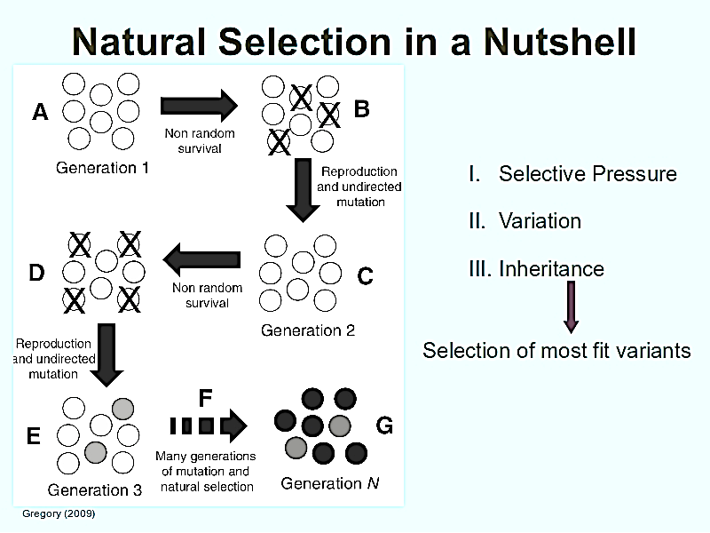
If these four conditions are met, then the new generation of individuals will be different from the original generation in the frequency and distribution of traits, which is pretty much the definition of biological evolution.
In addition, two other factors affect the genetic variability of a species
- Genetic drift: Either through a bottleneck (population crashes and greatly reduces number and diversity of population) or the founder effect (small group leaves to start anew…reduces number and diversity of population); the “new” population does not have the same frequencies or amounts of traits that were previously in the larger population
- Gene flow: organisms of the same species are able to move back and forth between areas to increase the variation of the population through sexual reproduction.

Evidence for Evolution
Previously, the main evidence for evolution was based on anatomy (structures) or physiology (functions) of organisms. Currently, comparing biochemical evidence (DNA, RNA, or protein sequences) provides scientists with the most detailed information. In general, the more similarities two organisms share, the more recently they diverged from a common ancestor.
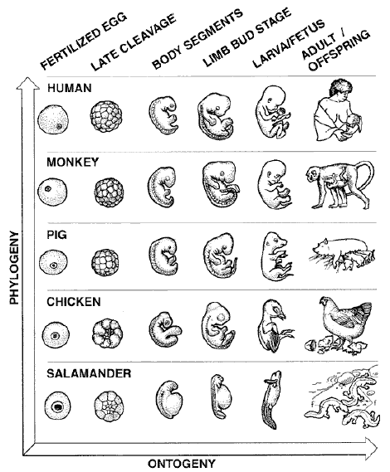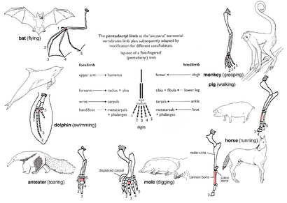
HOMOLOGOUS STRUCTURES are structures that have the same shape/form, but are used differently. The bones in the center are from the common ancestor, but each species has evolved to use them differently
EMBROLOGY compares the embryos of different species. The similar development patterns of the species above indicates that they shared a common ancestor

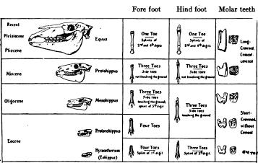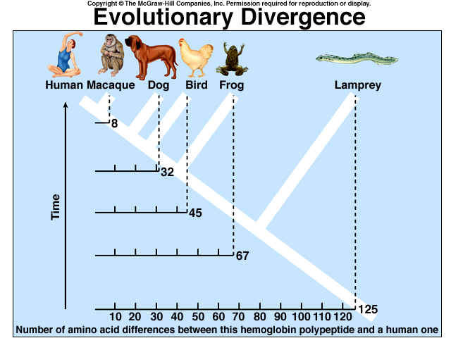
BIOCHEMICAL EVIDENCE compares the differences in either DNA or proteins (in this case, proteins. The lamprey has the most differences from humans, which indicates we diverged from the lampreys (are less related) much longer ago than the macaques (more related)
FOSSIL EVIDENCE links present day organisms to the common ancestors. Here we see the bones of modern horses (top) and how much it has changed from common ancestors (bottom)

Not shown are vestigial structures, which are structures reduced in size that are no longer needed but were present in a common ancestor (think of the human tail bone or wisdom teeth. In addition, whales have tiny little hip bones but no legs, which suggests that that the ancestor of the whale walked on land and returned to the sea!). Also not shown are analogous structures, which are structures that look the same but are made out of different materials. This shows that species have changed to adapt to the environment in a similar manner.

Ecology is the study of how organisms interact with their environment. There are many different levels of ecology. The diagram to the left shows all of the different levels
Topic 9: Ecology
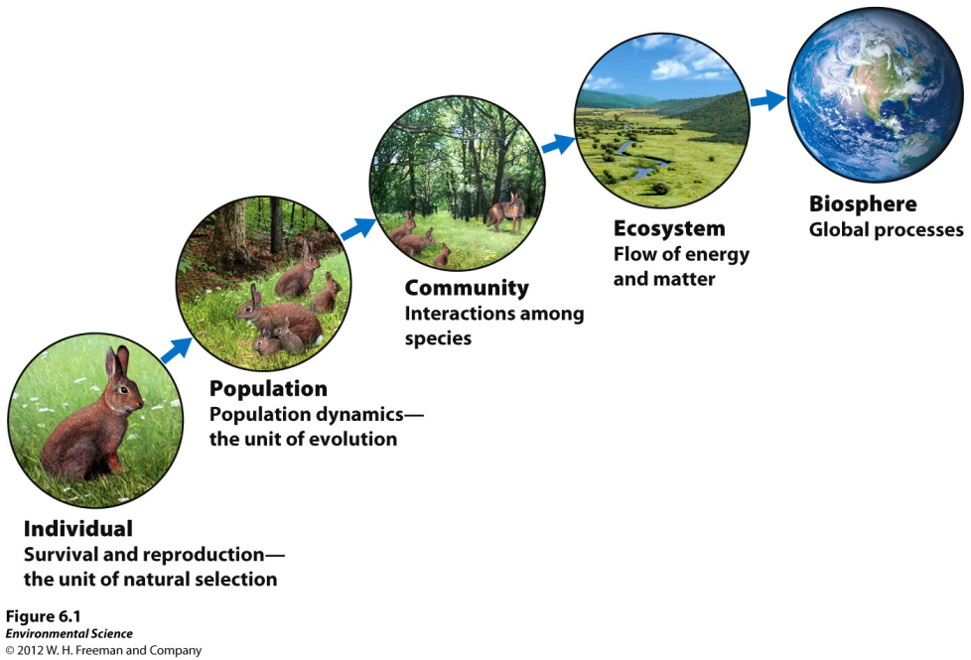
Ecosystems have both living components (biotic factors such as the trees, birds, and fish) and nonliving components (abiotic factors such as how much rain or sun an area gets). All ecosystems need energy, and the most basic form of energy comes from the sun. Producers (also known as autotrophs) are able to make their own food. These are eaten by consumers (also known as heterotrophs). We can track the flow of energy linearly using a food chain or look at a more detailed flow of energy using a food web.

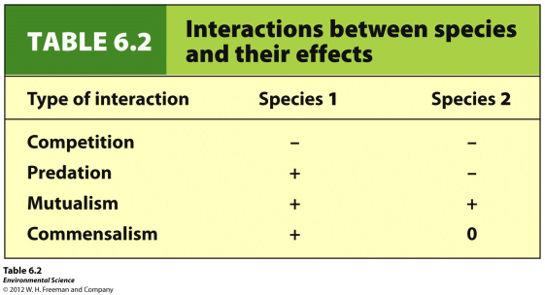
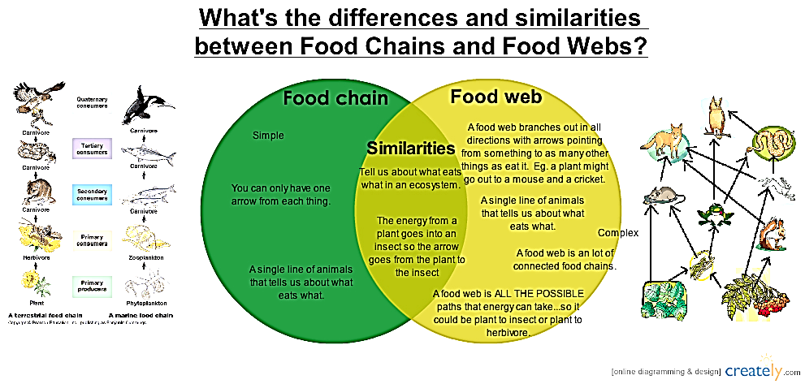
Organisms can interact with each other in many different ways. Symbiosis is the general term for organisms that closely interact with each other. There are three different types of Symbiosis: parasitism, mutualism, and commensalism. The table to the right shows some of the different ways different organisms can interact with each other.

A limiting factor is some sort of factor (biotic or abiotic) that is going to limit the population’s growth. It could be an important nutrient that is cycled through the ecosystem (such as water, nitrogen, carbon, or phosphorus), or it could be a food source or predator. A great example of limiting factors are predator-prey graphs. It is easy to see how the size of the population is affected.

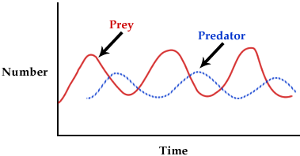
Here, the size of the populations depends on the number or prey and predators. The predator population peaks after the prey population because of the lag time in reproduction. When the predator population is at its highest, the prey is at its lowest. With limited food, the population size of the predator decreases. This allows the prey population to increase, and the cycle continues again…

Nutrient Cycles
Important nutrients such as carbon, nitrogen, phosphorus, and water are cycled through living things and the environment through biogeochemical cycles. The following pictures are overviews of the carbon, phosphorous, and nitrogen cycles.
Carbon Cycle
Nitrogen Cycle
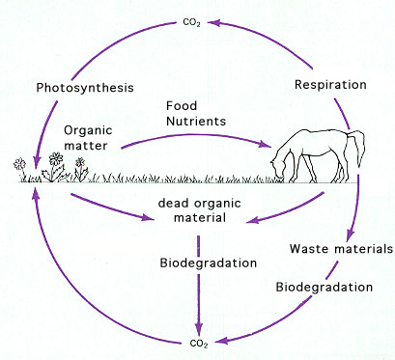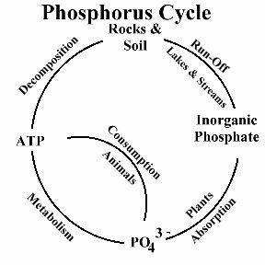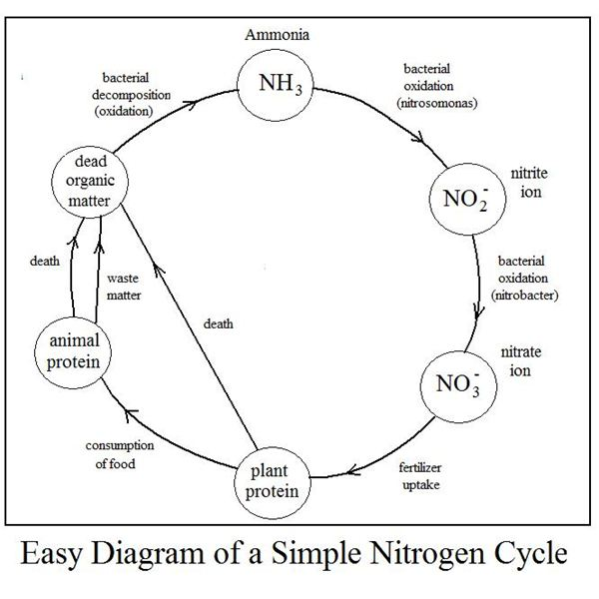

These natural processes are affected by human involvement. The table below shows how humans change the cycles:

Cycle Disturbance/problem | Ecosystem Effect
Hydrologic /deforestation and paving | ↓ evapotranspiration, ↑ runoff, ↑ erosion, ↑ flooding
Carbon/fossil fuel combustion and deforestation | ↑ CO₂ levels, ↑ atmospheric heat retention, ↑ global warming
Nitrogen/excess (fertilizers, pig farms) | ↑ Atmospheric N₂, change of diversity (eutrophication)
Phosphorus/excess (fertilizers, detergents, bird/bat guano) | Algal bloom, change of diversity

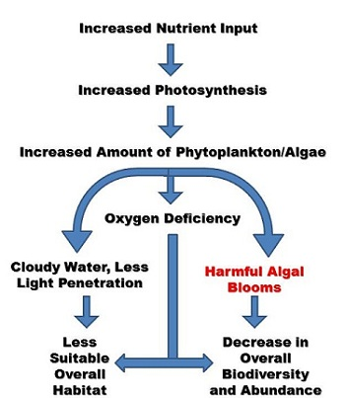

Eutrophication is a term that demonstrates how changing nutrient levels affect the organisms in an ecosystem. For eutrophication, and increase of nutrients (usually nitrogen and phosphorus because they are limiting nutrients) is added. This increases photosynthesis (sometimes called an algal bloom because the algae covers the top of the body of water), and as these producers die, the decomposers come in to feed off of them. These decomposers are going through respiration and lower the oxygen available to all organisms that can cause many to die.

